AZ RXI Staging Area Regular

User Documentation
Version 0.4


Contents
1 Document control 4
1.1 About this document 4
1.2 Changes made to this document 4
1.3 Purpose of this document 4
1.4 Audience for this document 4
2 Assumptions and constraints 5
3 Quarterly Data 6
3.1 PROCESS 6
References 8

Document control

About this document

Author | Anika Nower
Published
File location
Status | Released
Confidentiality | This document is confidential and must not be distributed outside of IMS Health.
Copyright | © 2026 IMS Health Incorporated or its affiliates. All rights reserved.

Changes made to this document

Version | Sections changed or created | Date of change | Author or contributor name | Role | Change summary
0.4 | all | 29.11.2013 | Anika Nower |  | Forth release

Purpose of this document
The purpose of this document is to describe a MSD HUNGARY generation process overview.

Audience for this document
This document has been written for:
- Production team members

Assumptions and constraints

ID | Assumptions

ID | Constraints

Monthly Data
Note: all files are located on the following FTP server
URL: ip: 162.44.12.94,userId: lndsftp01\ProdFTP,passWord: pinftp1
/Prods/IMSFTP2/ALD/ADAM/yy month name yyyy

Suppose for april’12: /Prods/IMSFTP2/ALD/ADAM/10 October 2013/10 RXI 2013/
Informed by email: Client Service Delivery Team will send us a mail that contains the confirmation about input is ready in ftp server From Vimal (VRevankar@uk.imshealth.com).
Before that
Pharbase Id come from Soumaya (Soumaya.Bahouss@astrazeneca.com) or data team (Data.Team@astrazeneca.com), Astrazeneca Data Team file named “AZ Practice List MonthName .xls” (excel file containing column “Pharbase Id”,” Account Description”,“POST5code”, “Status”).

** Pre PROCESS
Usually Soumaya Sends a mail to us before 19th each month. If not,then
we have to send a request Mail for Pharbase File:
Request mail sample:
To: Data.Team@astrazeneca.com;
CC: elaw@uk.imshealth.com;
Paul.Kirby@astrazeneca.com;
LNDA-IMProdSupp@bd.imshealth.com;
Subject: AZ practice List
Hello Team,
Please send us the MONTH_Name AZ practice list so that we can run our system.
Thanks in advance.

Signature Ex:
Thanks.
Regards,
Anika

Anika Nower
Software Engineer, Global Technology Services & Operations

IMS Dhaka
M&H Informatics (BD) Ltd.
Noor Tower
1-F Free School Street
73 Sonargaon Road
Dhaka-1205, Bangladesh

Mail: ANower@bd.imshealth.com
Phone: + 880-2-9632083, 9632084, 9632085, 9632086
Fax: + 880-2-9615805

www.imshealth.com

** Pre PROCESS (Check if change Request)
After a certain month period Angela (SMason@uk.imshealth.com;) generally sends a change request for updating “AZ_Bridge” table in database. That change request mail contains a bridge file(.xls format) So on production time “AZ_Bridge” table in database should be updated by this (.xls) file.

Update Action:
- Database Location:
ip: 162.44.193.192
UserId: PINASVC-IMAdmin
Password: !nf0_MgmT
Domain: INTERNAL
Desktop :: Enterprise Mangler→ Microsoft SQL Servers→SQL Server Group→ PINSSQL03(Windows NT)→Database→ AZ RXI→ Tables → AZ_Bridge

- Go to appropriate database location and take a back up for “AZ_Bridge” table.
For example create a backup table named as: “AZ_Bridge_YYYYMM”
Execute SQL command:
Insert into AZ_Bridge_YYYYMM
Select * from AZ_Bridge
Then check AZ_Bridge_YYYYMM table whether it contains all the data of AZ_Bridge. If transfer is occurred succesfully
Then execute,
Truncate table AZ_Bridge
- Then match with the given .xls file and “AZ_Bridge” table. There should be some common column which are need to insert from excel file to “AZ_Bridge” table.
- Using Export-Import wizard manager Import all the of excel file to table: AZ_Bridge

PROCESS

Process steps
Note: All essentials are located on the following location on 162.44.193.192:
Log on to server:
ip: 162.44.12.72
UserId: PINASVC-IMAdmin
Password: !nf0_MgmT
Domain: INTERNAL

Step | Action
1 | Create corresponding folder and take backups in  D:\AZ_RXI\Input\yyyymm  Go to 162.44.12.72, Open FileZilla and connect  ip: 162.44.12.94,userId: lndsftp01\ProdFTP,passWord: pinftp1, Location From Mail  [example: /Prods/IMSFTP2/ALD/ADAM/10 October 2013/10 RXI 2013]  Download them to: D:\AZ_RXI\Input in 162.44.12.72.  Eleven input files are available.  1. A0292Exxxxx.zip  2. A0293Exxxxx.zip  3. A0294Exxxxx.zip  4. A0295Exxxxx.zip  5. A0296Exxxxx.zip  6. A0297Exxxxx.zip  7. A0298Exxxxx.zip  8. A0299Exxxxx.zip  9. AV295Exxxxx.zip  10. AV297Exxxxx.zip  11. AV298Exxxxx.zip  Take backups for outputs by creating folder  D:\AZ_RXI\Output\  Take backups for Pharbase Id by creating folder  D:\AZ_RXI\Pharbase_Input
2 | Open enterprise manager and open databases, right click on AZRXI database
4 | check tables→yearmonth lookup→right click on it→open table→all row
5 | See the latest previous month in above row.
6 | Place the inputs in (don’t unzip)  D:\AZ_RXI\Input\  Make sure every zip is OK/not corrupted (to make sure, View each file in corresponding 3file b winzip)  Place the Pharbase file (“AZ Practice List MonthName .xls” rename as “Pharbase.xls”) in  D:\AZ_RXI\Pharbase_Input  Open the excel file and make sure Pharbase Id excel in the correct format, naming convention.  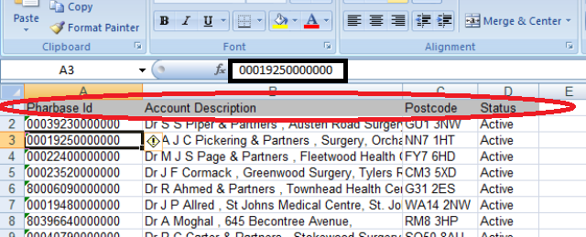  Make sure column header is there. And also Pharbase id number format should be same for each cell.
7 | Open Enterprise Manager and open the local package AZ RXI v2 (live) dtsx package. (Microsoft SQL Servers > SQL Server Group > PINSSQL03 (Windows NT) > Data Transformation Service > Local Packages :: AZ_RXI v2)
8 | Run the package Packages :: AZ_RXI v2  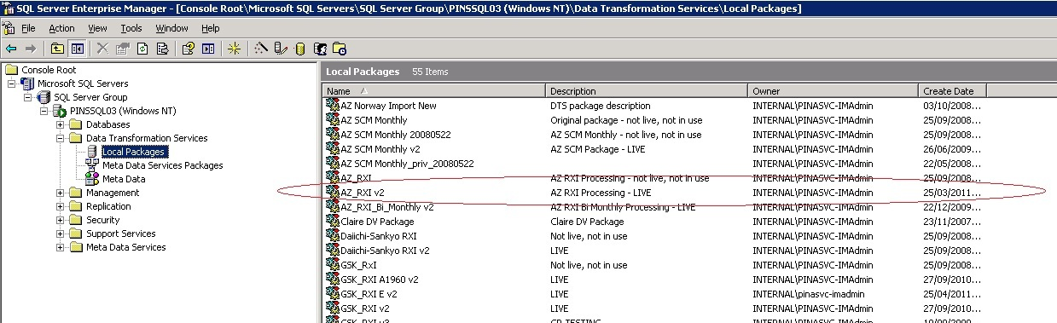
9 | After finishing package take backup for latest database.
10 | Right click on AZ RXI→All tasks→backup database→remove exiting file→add new file with name→ok in location E:\Az RxI Back up
11 | Output will generate in D:\AZ_RXI\Output\
12 | Copy ADP file and DDL file from previous folder and update it with current period.  Three changes in .DDL file.  1.To update the .DDL file see any input .ZIP file. Every input .zip file contain one .DDL file which have the current period range. Copy from there and paste into AZRXI.DDL D:\AZ_RXI\Output.  2. production date  3.At top portion month name and year
13 | Run ALOAD with properties:  0 Line number  , Delimeter
14 | Rename PractToTerr_YYYYMM.txt with appropriate period.  Then from D:\AZ_RXI\Output, zip the following 12 file into AZ_RXI_DVIEW_201306.zip. with winzip  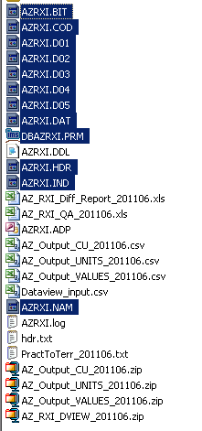
15 | Please Load AZ_RXI_DVIEW_YYYYMM.zip with system utilities and check the dataview successfully open or not.  Then upload 7 file into dedicated ftp location (see below mail example) and inform client to check and wait for confirmation.  7 files:  AZ_Output_CU_YYYYMM.zip  AZ_Output_UNITS_YYYYMM.zip  AZ_Output_VALUES_YYYYMM.zip  AZ_RXI_DVIEW_YYYYMM.zip  AZ_RXI_Diff_Report_YYYYMM.xls  AZ_RXI_QA_YYYYMM.xls  PractToTerr_YYYYMM.txt  Mail Example:  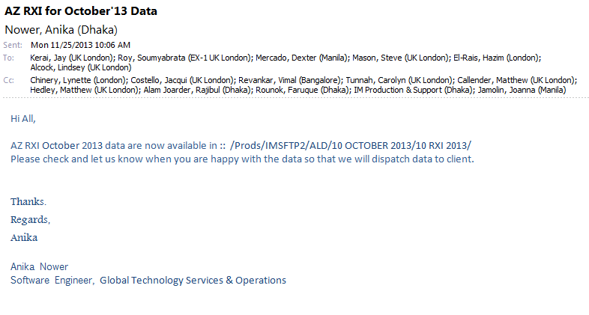  Please follow this distribution list:  To: Roy, Soumyabrata (EX-1 UK London); DMercado@ph.imshealth.com; SMason@uk.imshealth.com; HElrais@uk.imshealth.com; Jknight@uk.imshealth.com;  Cc: LChinery@uk.imshealth.com; JCostello@uk.imshealth.com; VRevankar@in.imshealth.com; MCallender@uk.imshealth.com; MHedley@uk.imshealth.com; RAlamJoarder@bd.imshealth.com; frounok@bd.imshealth.com; LNDA-IMProdSupp@bd.imshealth.com; JJamolin@ph.imshealth.com;  Subject: AZ RXI for Mmmmm’13 Data
16 | Then 1 confirmation mail comes from Dexter and Steve to dispatch to AZ.
17 | Now from 162.44.12.72  https://securnet.imshealth.com/  Each file should be sent from each individual page.  Now log on to 162.44.129.64  ID: dacasvc-gdcrdpadmin  Password: !nf0_MgmT  Go: D:\Transfer\Simple Mail Client (Final)\Simple Mail Client (Final)  Open the SimpleMailClient.exe file. To get detail information for sending this mail please follow :  AZ IMS Health Delivery.doc  From:  D:\Transfer\Simple Mail Client (Final)\Simple Mail Client (Final)\don't delete_mail format_nadeem  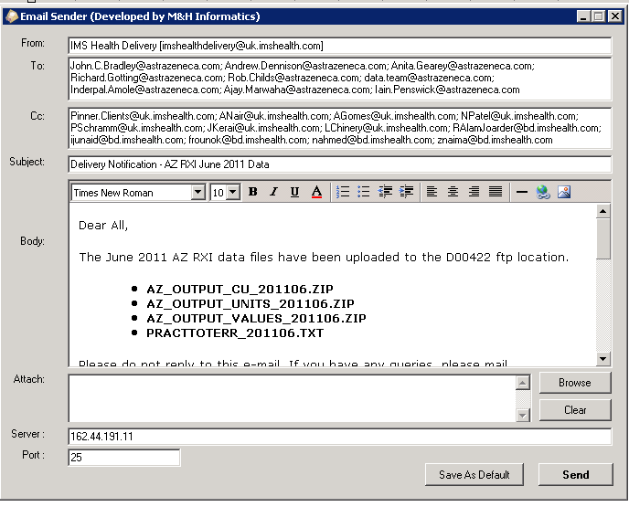
  User Id: RAlamJoarder@bd.imshealth.com  Password: 02Athens  Select the tab >>Drop off Tool  Encryption checked  AZ RXI - D00422 --AstraZeneca | 9:58
  ralamjoarder@bd.imshealth.com  ijunaid@bd.imshealth.com  frounok@bd.imshealth.com  ANower@bd.imshealth.com  Ashfaq.Hossain@bd.imshealth.com | 9:59
  AZ_Output_VALUES_yyyymm.zip
  AZ_Output_UNITS_yyyymm.zip
  AZ_Output_CU_yyyymm.zip
  PractToTerr_yyyymm.txt
IMS Health Delivery [imshealthdelivery@uk.imshealth.com]

John.C.Bradley@astrazeneca.com; Andrew.Dennison@astrazeneca.com; Anita.Gearey@astrazeneca.com; Richard.Gotting@astrazeneca.com; Rob.Childs@astrazeneca.com; data.team@astrazeneca.com; Inderpal.Amole@astrazeneca.com; Ajay.Marwaha@astrazeneca.com; Iain.Penswick@astrazeneca.com

Pinner.Clients@uk.imshealth.com;NPatel@uk.imshealth.com; PSchramm@uk.imshealth.com; LChinery@uk.imshealth.com; RAlamJoarder@bd.imshealth.com; ijunaid@bd.imshealth.com; frounok@bd.imshealth.com; ANower@bd.imshealth.com; LNDA-IMProdSupp@bd.imshealth.com;

Delivery Notification - AZ RXI Mmmmm 2013 Data
Dear All,
The Mmmmm 2013 AZ RXI data files have been uploaded to the D00422 ftp location.
• AZ_OUTPUT_CU_201301.ZIP
• AZ_OUTPUT_UNITS_201301.ZIP
• AZ_OUTPUT_VALUES_201301.ZIP
• PRACTTOTERR_201301.TXT
Please do not reply to this e-mail. If you have any queries, please mail IMHarewoodProdSupp@uk.imshealth.com and a member of our Implementation Services team will assist you.
Kind Regards
Delivery team
Commercial Implementation Services EMEA
IMS Health

www.imshealth.com

The information contained in this communication is confidential and is intended only for the use of the recipient named above. If the reader of this message is not the intended recipient, you are hereby notified that any dissemination, distribution, or copying of this communication is strictly prohibited. If you have received this communication in error, please re-send this communication to the sender and delete the original message or any copy of it from your computer system. Thank You.

References
The table below lists other materials that are relevant to this document.
Title | Author | Version | Date | Location

